ECPHRASTIC POETRY ACTIVITY
BIOLOGY

Using the given stimulus material, create the following types of poetry:
- Free verse
- Acrostic
- Cinquain
- Haiku
- Limerick
Remember to complete the following steps:
- View a stimulus image and identify a biology-related concept it evokes.

- If required, write down the concept, definition, law, formula etc.

- Identify a suitable poetry type and write the poem.

STIMULUS IMAGE 1
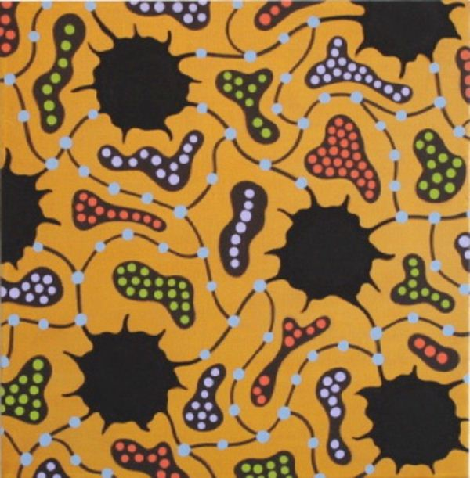
http://www.sciencefriday.com/slideshows/daytonslide/600_450/max.jpg
STIMULUS IMAGE 2
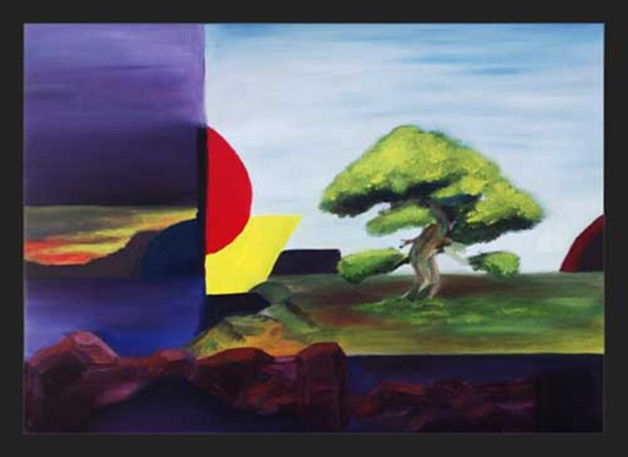
http://www.wetcanvas.com/Community/images/17-Sep-2009/26096-SpiritOfTheBonsai.jpg

STIMULUS IMAGE 3
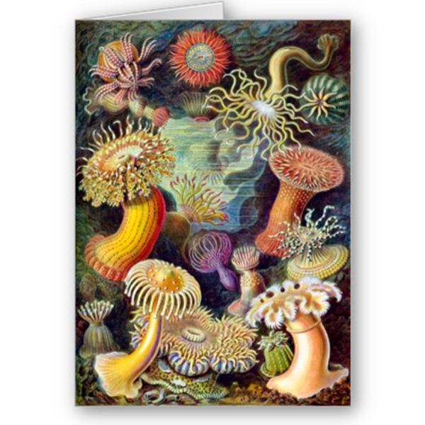
http://www.zazzle.co.uk/actiniae_illustration_painting_germa_ernst_haeckel_card-137549220884959491
STIMULUS IMAGE 4
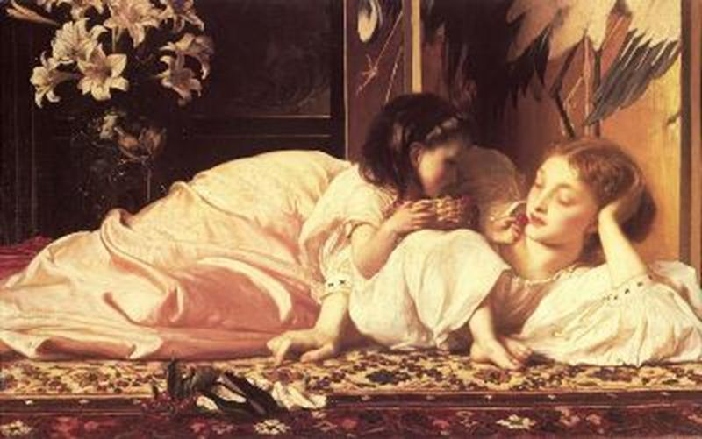
http://www.oilpainting.ws/upload/Classic-reproduction/Lord%20Frederick%20Leighton/mini/Leighton_Mother_and_Child.jpg

STIMULUS IMAGE 5
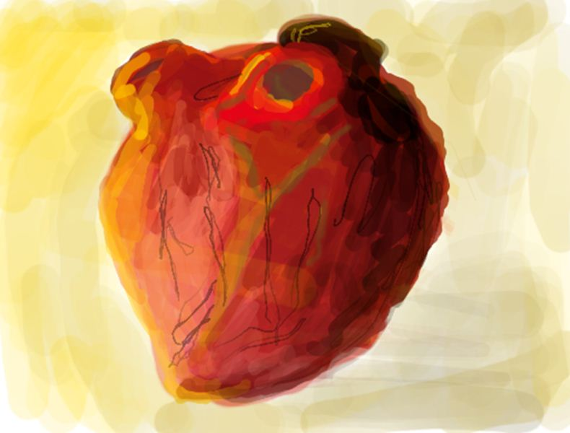
http://othep.files.wordpress.com/2007/12/colors_slot7.png

